Multiple-choice section

|  |  |  |  |  |  |  |  |  |  |  |  |  |
| --- | --- | --- | --- | --- | --- | --- | --- | --- | --- | --- | --- | --- |
| Question | 1 | 2 | 3 | 4 | 5 | 6 | 7 | 8 | 9 | 10 | 11 | 12 |
| Answer | D | C | D | C | B | D | C | C | A | D | C | D |

Question 1 [6.1]

D

The measuring jug is the tallest container as it is the highest point on the graph.

Question 2 [6.1]

C

Section *F* is the section where the graph begins to slope downwards as the distance from home decreases*.*

Question 3 [6.2]

D



Question 4 [6.2]

C

All points on the *x*-axis have a *y*-coordinate of zero. (2, 0)

Question 5 [6.2]

B

Each column of numbers in the table is an ordered pair (coordinate).

Question 6 [6.2]

D

(-3, 2)

All points on the graph *y* = 2 have a *y*-coordinate of 2.

Question 7 [6.2]

C

For  When *x* =3, *y* = 2 × 3 + 1 = 7, so the point (3, 7) is on the line.

Question 8 [6.3]

C

*y* = *x* + 2 is true for all pairs of values.

Question 9 [6.2]

A

The line with equation  crosses the *y*-axis at (0, 1).

Question 10 [6.2]

D

*y* = 1 is a horizontal line, so the gradient is equal to 0.

Question 11 [6.2]

C

The line with equation  has a gradient of 10 which means that the line is very steep.

Question 12 [6.4]

C

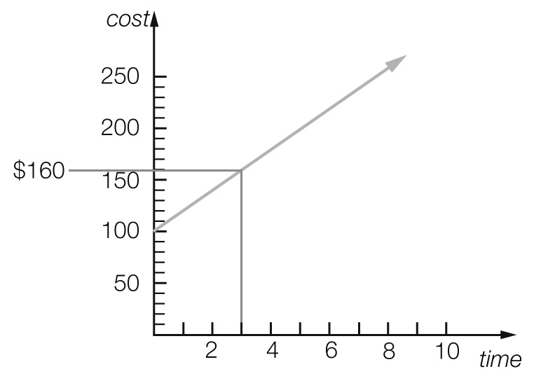

*C* = $160

Multiple-choice total marks: 12

Short answer section

Question 13 4 marks [6.2]

(a) Lines with a *positive* gradient *slope* up to the right and lines with a *negative* gradient *slope* up to the *left*.

(b) The *gradient* of a line is a measure of its steepness.

(c) The *x*-intercept is where a line crosses the *x-axis* and the *y-intercept* is where a line crosses the *y*-axis.

(d) The point (0, 0) is the *origin* of the *Cartesian* plane.

Question 14 3 marks [6.2]

(a) True

(b) False

(c) True

Question 15 3 marks [6.1]

(a) Height and weight (the axis labels)

(b) Sharon (the point lying the most to the left)

(c) Sharon (the highest point on the graph)

Question 16 2 marks [6.1]

(a) *A*. Steeper lines show faster speeds.

(b) *B*. Horizontal lines show no movement.

Question 17 3 marks [6.2]

*A* = (4, 3), *B* = (1, -3), *C* = (-4, 5)

Question 18 2 marks [6.2]

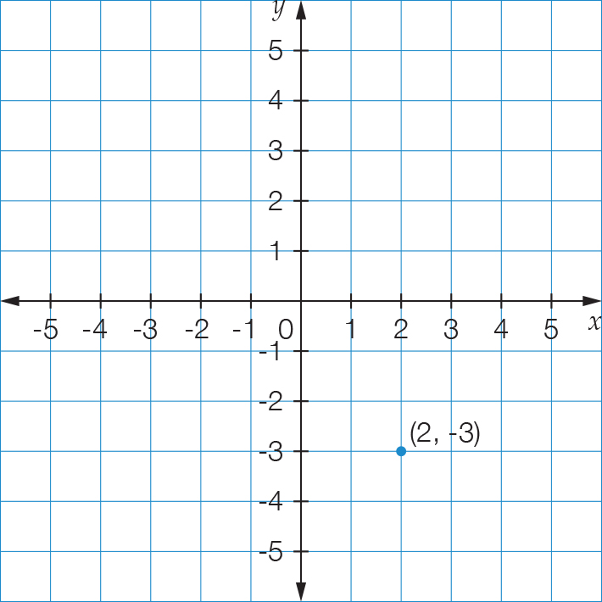

No, the two points are not in the same position, as the first number in an ordered pair represents the value of *x* and second number represents value of *y*.

Question 19 6 marks [6.2]

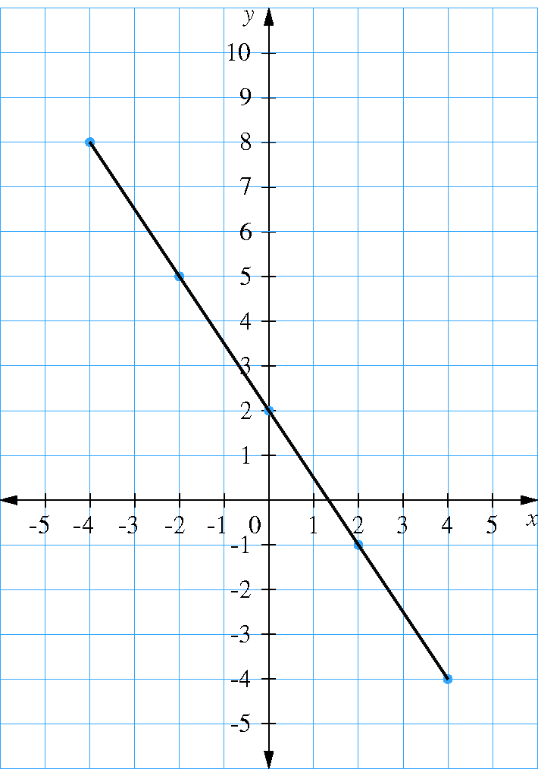

Question 20 4 marks [6.2]

For the line with equation: *y* = -5*x* – 10

(a) For *x* = 2, *y* = -5  2 -10 = -20: (2, -20)

(b) For *x* = -1, *y* = -5  -1 -10 = -5: (-1, -5)

(c) For *x* = -2, *y* = -5  -2 -10 = 0: (-2, 0)

(d) For *x* = 3, *y* = -5  3 -10 = -25: (3, -25)

Question 21 1 mark [6.3]

Gradient of zero passing through (-2, 1). Rule: 

Question 22 1 mark [6.3]

Vertical line through (4, -2). Rule: 

Question 23 4 marks [6.3]

(a) *m* = 1, *c* = 4, 

(b) *m* = 3, *c* = 0, 

Short answer total marks: 33

Extended answer section

Question 24 6 marks [6.1]

(a)

|  |  |  |  |  |  |
| --- | --- | --- | --- | --- | --- |
| Distance from start (km) | 0 | 500 | 500 | 900 | 900 |
| Petrol in tank (L) | 60 | 10 | 60 | 10 | 45 |

(b)

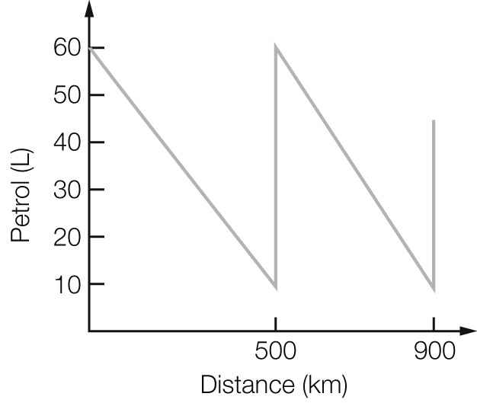

(c) The car used 50 L over 500 km (10 L/100 km) for the first part of the trip, and 50 L over 400 km (12.5 L/100 km) for the second part of the trip.

(d) The line falls more steeply for the second part.

Question 25 5 marks [6.3]

(a)

|  |  |
| --- | --- |
| Number of triangles  (*t*) | Number of matches  (*m*) |
| 1 | 3 |
| 2 | 5 |
| 3 | 7 |
| 4 | 9 |
| 5 | 11 |

(b) 

(c)

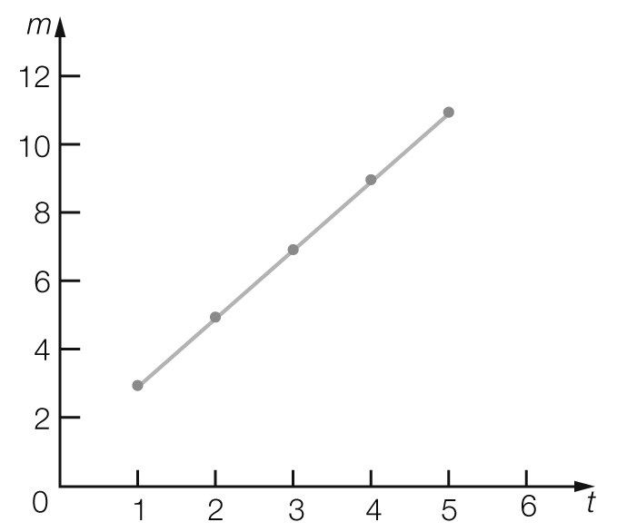

(d) For *t* = 20, *m* = 2 × 20 + 1 = 41

Question 26 5 marks [6.4]

(a)

|  |  |  |  |  |  |
| --- | --- | --- | --- | --- | --- |
| Hours worked, *t* | 0 | 1 | 2 | 3 | 4 |
| Cost, *C* | 50 | 70 | 90 | 110 | 130 |

(b)

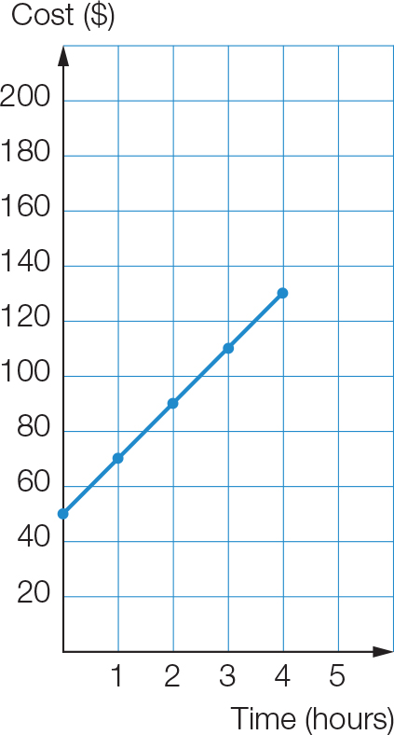

(c) $150

(d) *C* = 50 + 20*t*

Question 27 5 marks [6.4]

(a) $1.70

(b) 

(c) *T* = 1.5 + 0.2 × 20

= $5.50

Extended answer total marks: 22

TOTAL test marks: 67